Local Rules for Protein Folding on a Triangular Lattice and Generalized Hydrophobicity in HP Model
Richa Agarwala, Serafim Batzoglou, Vlado Dancik, Scott E. Decatur, Martin Farach, Sridhar Hannenhalli, and Steven Skiena
Journal of Computational Biology, Vol. 4, pp. 275-296, 1997
Abstract
We consider the problem of determining the three-dimensional folding of a protein given its one-dimensional amino acid sequence. We use the HP model for protein folding proposed by Dill, Which models protein as a chain of amino acid residues that are either hydrophobic or polar, and hydrophobic interactions are the dominant initial driving force for the protein folding. In this paper, we examine the choice of a lattice by considering its algorithmic and geometric implications and argue that triangular lattice is a more reasonable choice.
- Introduction
The protein folding problem STRING-FOLD is that of finding a conformation of the protein sequence on the lattice such that the overall energy is minimized, for some reasonable definition of energy. The lattice formulation described so far leaves open two important questions: what type of lattice should one use; and what energy function is appropriate.
- Rules for Two Dimensions
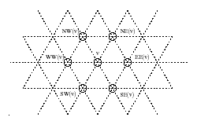
Lemma 2.1 For every conformation f of binary sequences S in the two dimensional triangular lattice
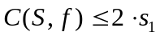
where 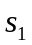 is the number of H’s in S
- Backbone-folding: a 1/4-Approxinmation
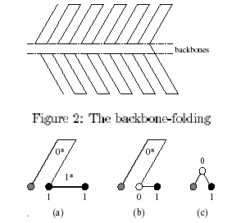
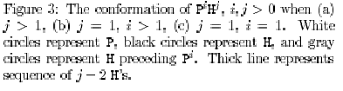
Lemma 2.2 Let 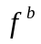 be the backbone-folding of binary sequence S. Then 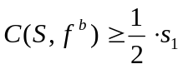
- Arrow-folding: a 1/2 Approximation
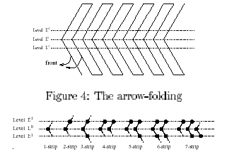
Lemma 2.3 Let 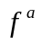 be the arrow-foldingg of binary sequence S. Then 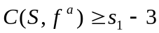
3. Rules for Three Dimensions

Lemma 3.1 For every conformation f of S on a three dimensional triangular lattice
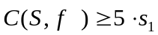
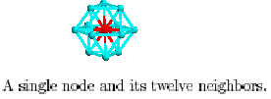
- Backbone-folding: a 3/10-Approxinmation
Lemma 3.2 Let 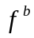 be the 3D backbone folding of sequence S on the three dimensional triangular lattice.
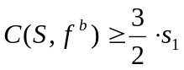
- Arrow-folding: a 7/15 Approximation
Lemma 3.3 Let be the 3D arrow folding of sequence S on the three dimensional triangular lattice.
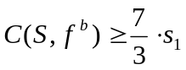
- Star-folding: a 16/30 approximation
Lemma 3.4 Let 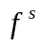 denote star-folding of S on the three dimensional triangular lattice.
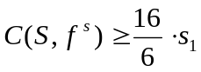
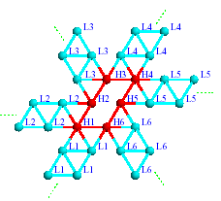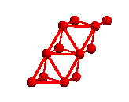
Created by: Chia-Chang Wang
Date: June 18, 2004

